
Rebirth of Kosova Church wishes you a
Merry Christmas
&
a Happy New Year
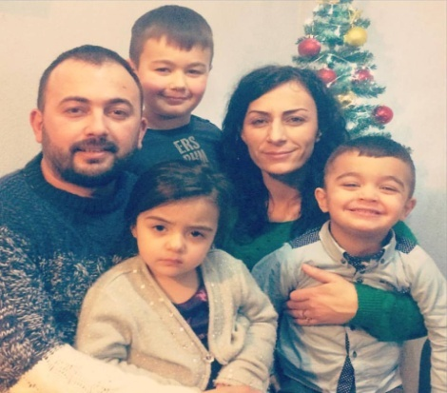
Dear brothers and sisters, we want to begin this Newsletter thanking God for each one of you; for your prayers, mission trips and financial support for Rebirth of Kosova Church. Flora and I are very thankful for you, and in our prayer devotions we do pray and bless each one of you. We bless you and your ministry in whatever you do to increase God’s Kingdom in this world.

This year we believed like never before that Kosova needs Christ; His love, peace and Joy more than ever. We believed we needed to be with the people, live with them, cry and rejoice with them.
The Church in Action. 2015 was a year of life, growth and stability for our ministry. Our church grew stronger this year and God has demonstrated in many many ways His presence, love and faithfulness towards us.
We want to thank everyone who, throughout the year, helped us cover the rent expenses for the church building. Thanks to you we were able to reach and serve the community from this place.
Thank you Petra Ministries - Pastor John Starr - London. Thank you Peter & Kimberly Morrison - Canada. Thank you Engjull and Claudia Bajrami - Kassel City Church, Pastor Michael Boker.


Here are some main events that have happened since our last NewsPrayer Letter
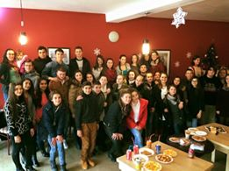
The Youth Ministry-
I must say that this has been an incredible year of growth in the youth ministry. We’ve had almost double the number of youth, and every single Saturday we have new ones that come to our community center. The highlights of this year were the two weeks’ outreach with Ryan Otter and more than twenty teenagers that spent their time with our youth and did a lot of activities. The other Highlight was the Youth Summer Encounter called the “ Holy Sprit Encounter” in Rugova Mountains. We want to thank Peter and Michelle Bates, Don and Marti Denham , Rebirth of Kosova Church and many others who financially supported this Youth Encounter. Thank you guys.
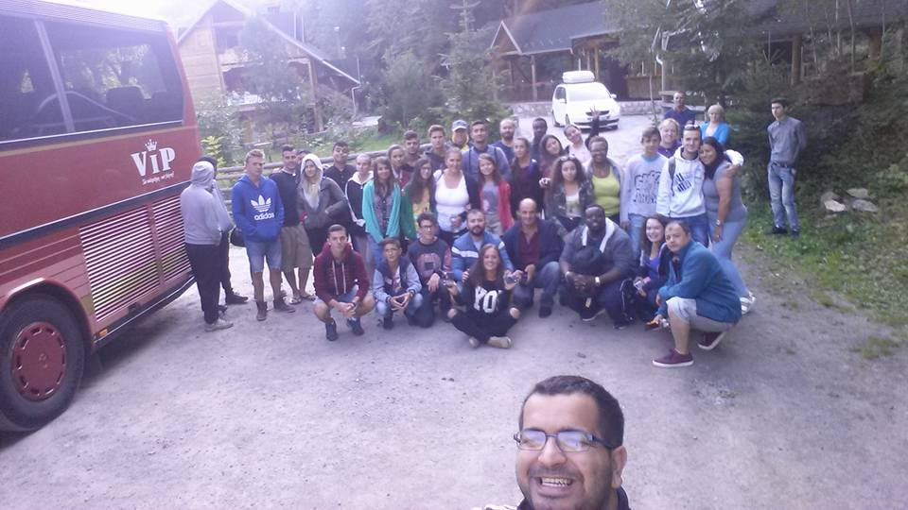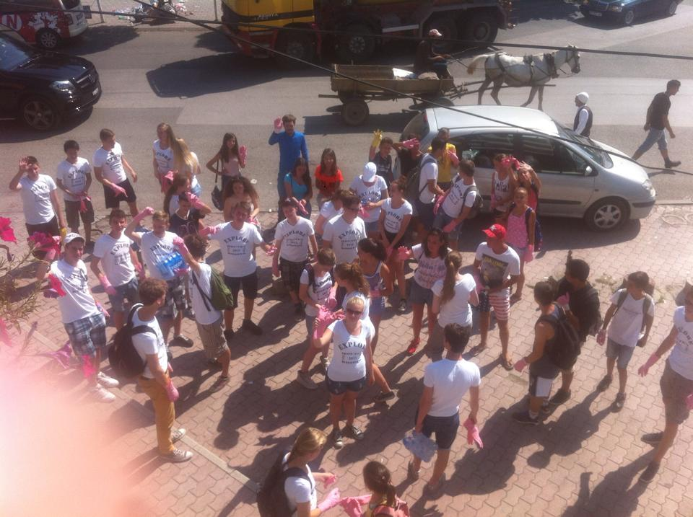
Cleaned the city, visited the poor and helped the needy.
The Three day Youth Encounter The two week outreach- ROK & Dutch Youth

Children’s Ministry;
Early this year a group from our church was trained for Children’s Ministry by CEF - Metush & Nora Kaja- who at the same time lead our children’s ministry. We’ve also had a growth in this ministry, and having other people from the church involved and trained to work with the children has really made a difference. Our children this year have been involved in many different activities, such as: three and one day camps, visits to swimming pools, plays etc.
Special thanks to World Challenge, Bettina Marayag for financally supportin the Summer Camps this year and making it possible to share the gospel with hundreds of children.

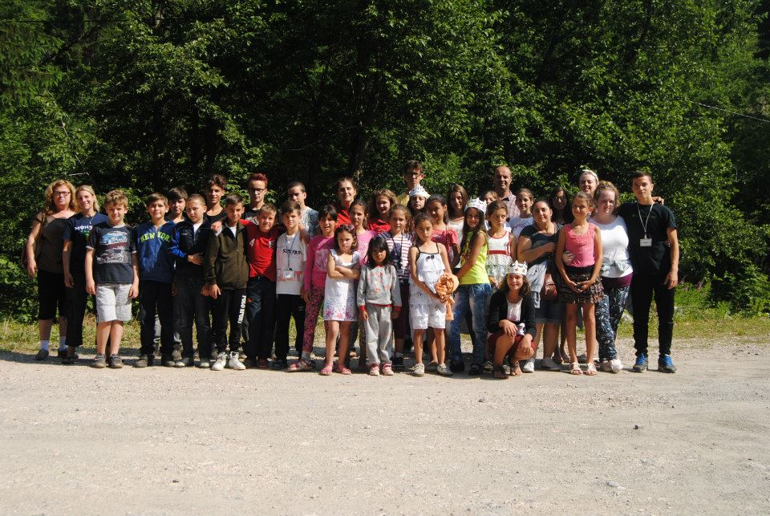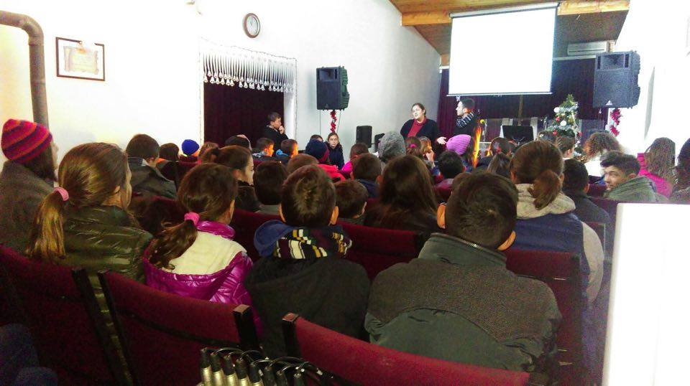
The Summer Camp in Peja The Children’s Meeting at Church

The Baptism – Thirteen people were baptized 2015
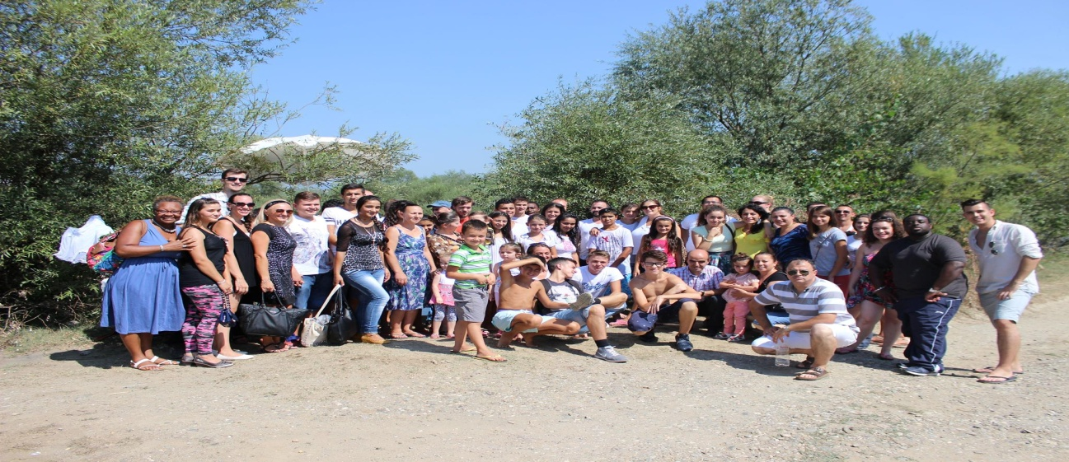
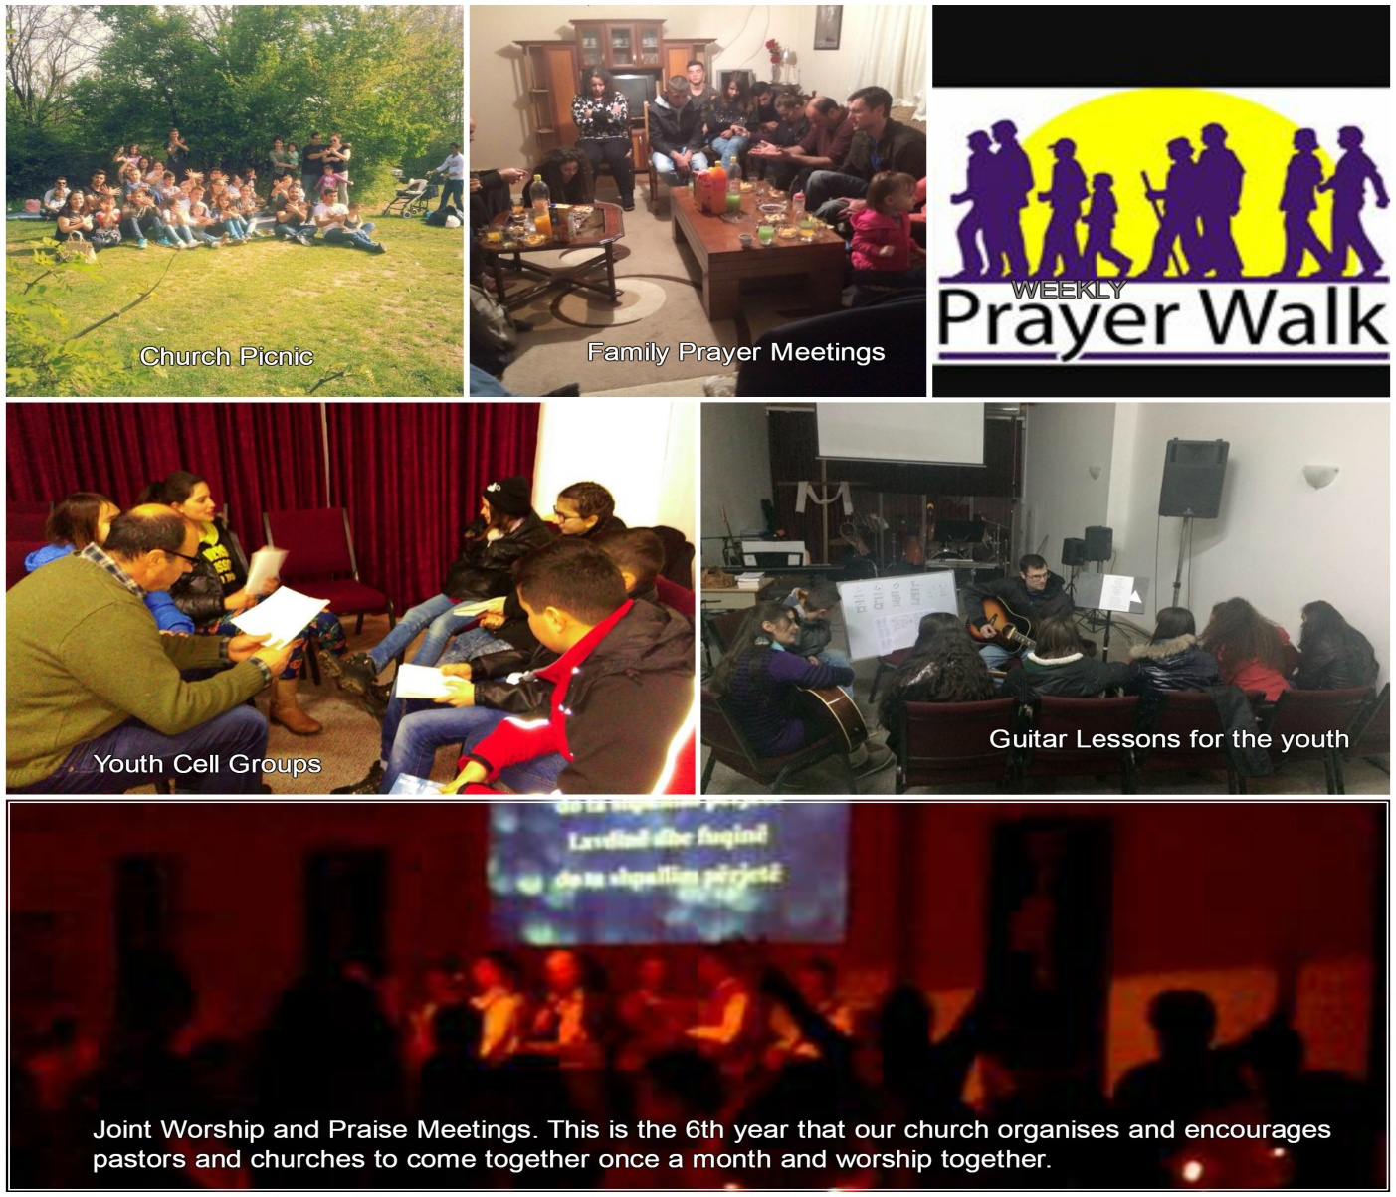
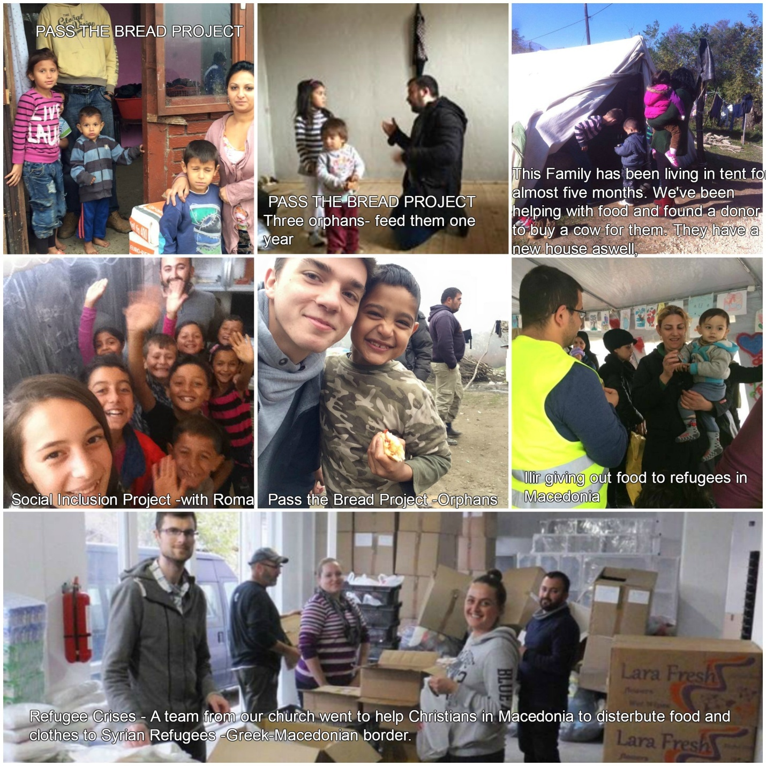
2016 PLANS / PROJECTS /VISION
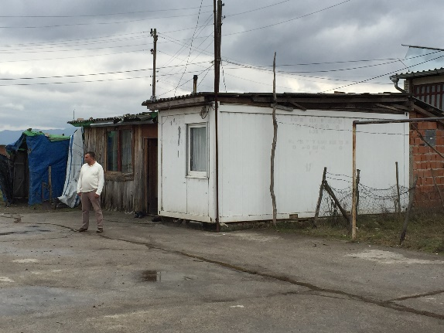
New Houses Project
You all know that since after the war we as a church have been serving more than 10 families that live in the village of Qerim, in Barracks and we have been praying for their houses. This year a Dutch NGO-New Day Impact, is looking very seriously into building 10 houses for these families. The municipality of Gjakova has agreed to give the families a piece of land so a village for these families can be built. Praise God for answering our prayers. Thank you New Day Impact for your ministry.
Radio Ministry 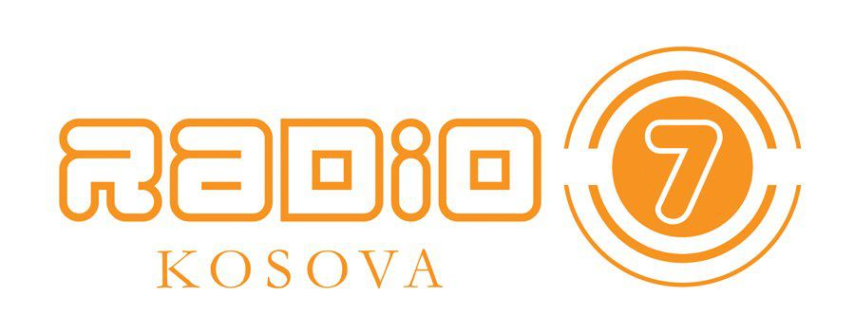
Radio 7 Kosova, is a Christian radio station based in Tirana, Albania. They have a second station in Fushe Kosova, and now they want to expand their frequencies by opening another station in Gjakova. Our church will be directly involved in this ministry, since we have expirience with radio ministry and this will open a place for someone to find a job. Thank you Jesus.

Prayer Requests :
- Please pray for the Vision and Mission of ROK Church. To continue to serve the nation in Jesus name, make desicples and bring love and light to the lost in the name of Jesus.
- Please pray for our Church Building Rent for 2016. We are in a very strategic location where our builiding is turned to be used as a community center. The rent is 500 euors per month. We have 200 from that amount covered by Petra Ministries , we need another 300Euros to be covered. Please pray with us.
- Church Transportation. We deperately need a van with 12 seats. We have a lot of families that live in villages and can’t come to church, and a lot of projects with youth and children will need lots of transportation this year. Please pray with us so we can have enough funds to buy a van.
- Property & Church Building. We believe God has put in our hearts this year to start praying for something that is beyond our capacity and cirmuctances. To pray for the land and the building of our church. We are growing every year and the need to have our own place is just at the door. The first people who gave 160 euros donation towards the church building/land were a Serbian Pastor and his wife. Please keep us in prayer and believe in this amazing vision with us that God has put in our hearts.
- Please pray for Ilir and Helen Dervishi as they have dedicated all their time to the church ministry and managing the King’s Café. They need financial support for the new year. Thank you for praying

Thank you for partnering with Rebirth of Kosova Church, and planting God’s seed of life in Kosova. We love you and can’t wait to see the great things God has for us in the brand new year ahead of us.
In Christ Alone. Jeton & Flora Sokoli

